MUSE: Machine-enhanced User Sound Experience Evaluation Report

1. Overview
MUSE is a prototype for an audio mixing tool designed to make sound enhancement simple and accessible. The tool allows users to upload an audio file and adjust elements such as vocals, instrumentals, or background layers. The goal of this study is to understand control preferences for MUSE based on an implemented prototype. This research represents a formative evaluation of a prototype for MUSE.

2. Research Questions
The study was guided by the following research questions:
- Do users feel the sliders give them adequate, immediate control over the mix?
- Does the AI-suggested gain preset feel appropriate and trustworthy? Would explanations or feedback increase users’ willingness to accept the suggestion?
- Over multiple saved mixes, do users perceive the model’s recommendations as improving and reflecting their taste?
- When mixing fails, do users understand what happened and how to recover (e.g., retry, re-upload, adjust file)?
- How do users split time between manual mixing and accepting AI presets? When do users switch between the two?
- Are progress indicators and status messages (separation, saving, applying settings) sufficient to keep users oriented?
- Do users understand that their personalized model and mixes live locally (per browser)? Does that affect perceived value or trust?
- How do users rate mixed output quality across genres?
- Over repeated sessions, does reliance on the AI suggestions increase, decrease, or stay stable?

3. Method
This study used an interview method. We interviewed five participants in person, one-on-one, and then collected feedback manually. We collected both quantitative and qualitative feedback on users’ preferences and experiences.

3.1 Participants

Participants were chosen based on whom we know. Specifically, within our labs (for the PhD students) or students within our batches (Master's).

3.2 Materials
Participants viewed our functional prototype and were asked to describe pain points or potential areas of improvement after playing with the prototype for some time.

3.3 Procedure
Participants answered questions about:
- Open-ended feedback explaining their choice and suggesting improvements
- Whether the sliders felt responsive enough and offered sufficient control
- How appropriate and trustworthy the AI-suggested gain preset seemed
- If recommendations improved across saved mixes and matched users’ evolving tastes
- How users interpreted mixing failures and what recovery actions they expected
- What drove users to switch between manual mixing and AI-generated presets
- Whether progress indicators and status messages provided enough orientation
- How users understood the local-only nature of personalization and how it influenced trust
- How users rated stem-separation quality, mix quality, and the artifacts that shaped dissatisfaction
Responses were collected via in-person interviews. Each interview lasted approximately 15 minutes and followed a set of questions.

3.4 Common Notes
Common notes between interviewees during the interview. Generally we observed positive reactions, however we did note a small number of concerns as well.
- Human-AI Workflow
Users treat the AI preset as a launchpad rather than an end state. They want robust controls to manage that handoff – undo/reset, A/B comparison, and snapshot/recall - so they can quickly converge on a preferred mix. Users noted that the system is well-designed and simple enough to be used without AI assistance as well.
- Control and Responsiveness:
Users were generally satisfied with slider responsiveness and the vertical slider format which we chose in Stage 2 after user feedback. We did not note much specific feedback regarding the slider format with this prototype.
- Trust and Genre Sensitivity:
Confidence in AI suggestions varies by genre. Explanations, “why” cues, or confidence indicators would strengthen trust and make it clearer when an AI preset is reliable vs manual intervention is needed.
- Personalization Efficacy:
Personalization signal improves noticeably, but is random at the beginning. Most users would prefer no AI suggestion to random suggestions at first, but once a history exists users found the AI suggestions to be more than satisfactory.
- Data Handling and Trust:
Local-only personalization increases privacy trust, but sets the expectation of no-cross device synchronization.
- Audio Quality:
Mix quality is quite strong in good recordings, but degrades where there exists very complex components in audio (for example - Indian pop music with complex electronic music). Users were satisfied with most tested inputs however, specifically those with more common instrumentals.

4. Results
Throughout our interviews, we noticed a few common suggestions or critiques shared by most or all of the interviewees. While we were able to implement some major fixes, other minor suggestions remain unresolved for now. This section will describe the critiques and our attempts to address them.

4.1 Real-time mixing
The initial prototype we demonstrated to the interviewees did not support real-time mixing. When the user wanted to remix an audio, they would need to stop, mix, and then replay the audio.

We found a quick front-end fix for this problem, where we would remix the original audio and continue to play the first mixed audio until the new mixed audio output had finished. Once finished, we would slowly fade out the old mixed audio and fade in the new audio, mimicking a seamless real-time transition.

4.2 Light Mode
Another common point was that our prototype was missing a light mode, as it was in a default dark mode. We solved this by adding a toggle button that would change the theme from dark to light.
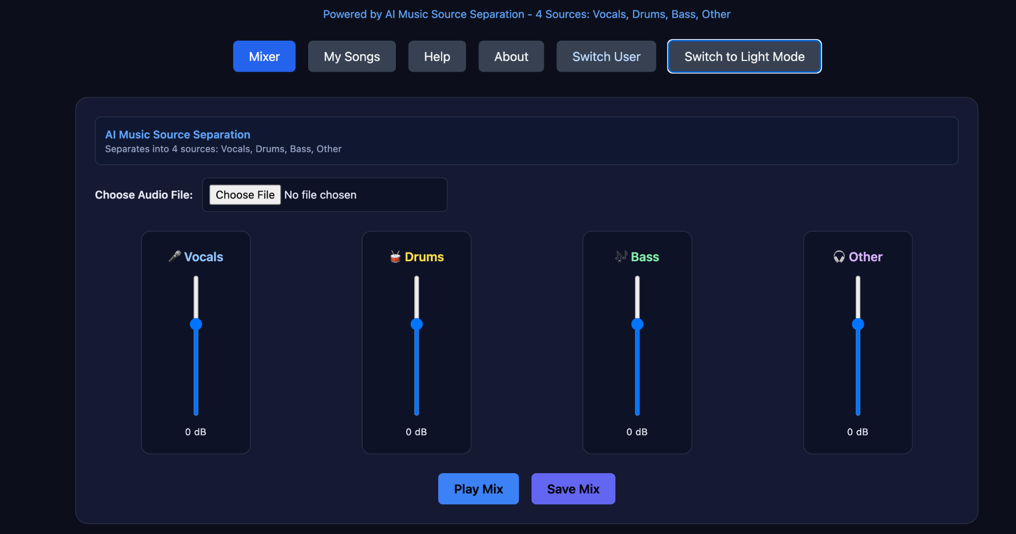
Dark Mode

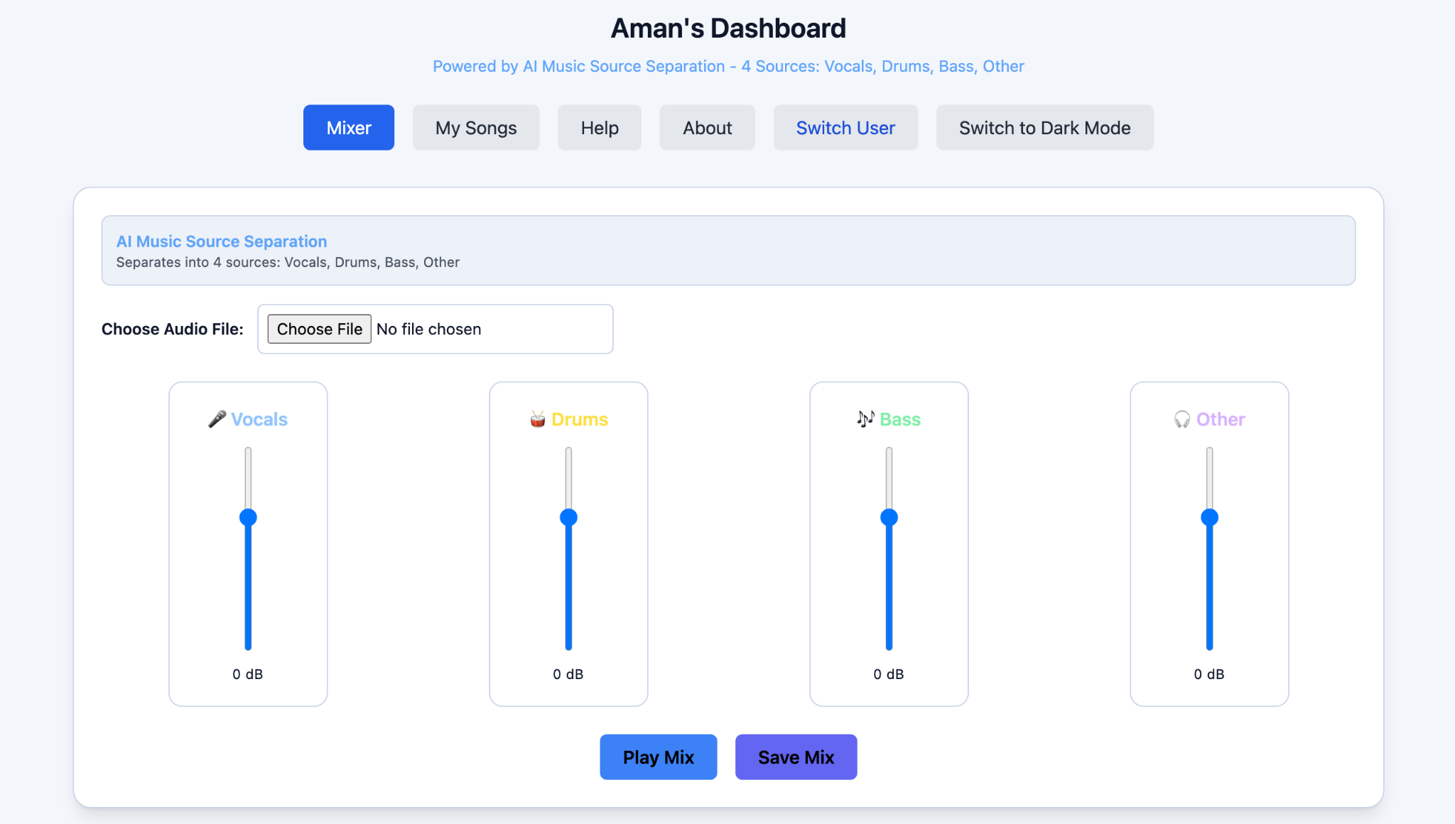
Light Mode

4.3 Help Pop-up
Some common feedback regarding the help menu/pop-up was that it was a bit unclear. Specifically because it only describes the general flow of the prototype, but does not actually reference the buttons in the prototype. Some suggestions included adding images of the buttons from the actual prototype.

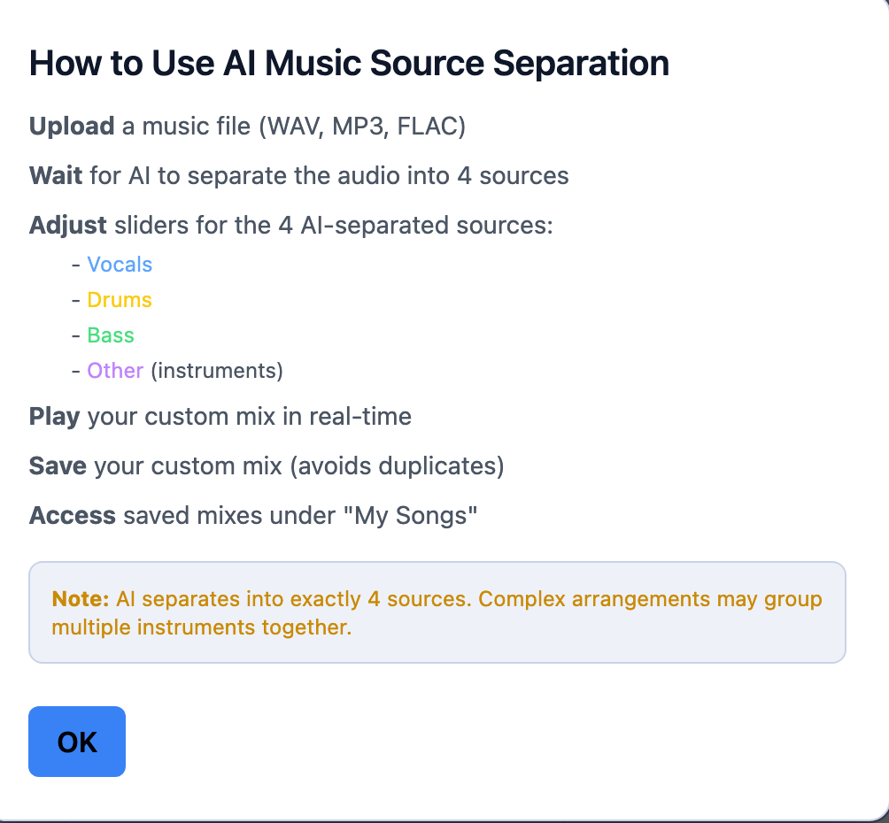
Help Menu

4.4 No Prior History
Many users indicated that the application would greatly benefit from tracking user history and user preferences, so this subsection details some of the updates we made to the original prototype in this regard.

4.4.1 My Songs Page
We added a page called My Songs, where the user can track mixes that they have created using the app and saved using the Save Mix button.
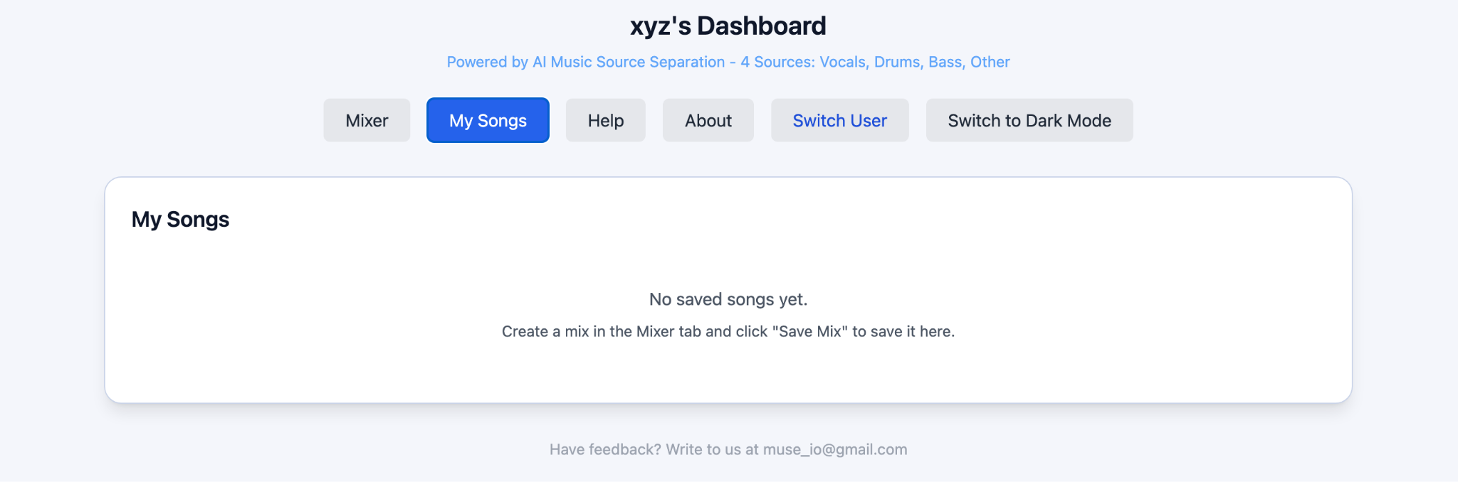
My Songs Page

4.4.2 AI Suggested Values Based on User History
Many users indicated that they would like to have AI-generated mixing options based on user preferences. This was one of our initial goals with the prototype, so we decided to implement it. We store each user's preferences for songs and use them to predict new mix values depending on the genre of the song, etc.

However, one issue we did notice was that our model would recommend random values for new users who did not yet have any history, which could lead to potential difficulties for the users especially if they are unfamiliar with mixing.

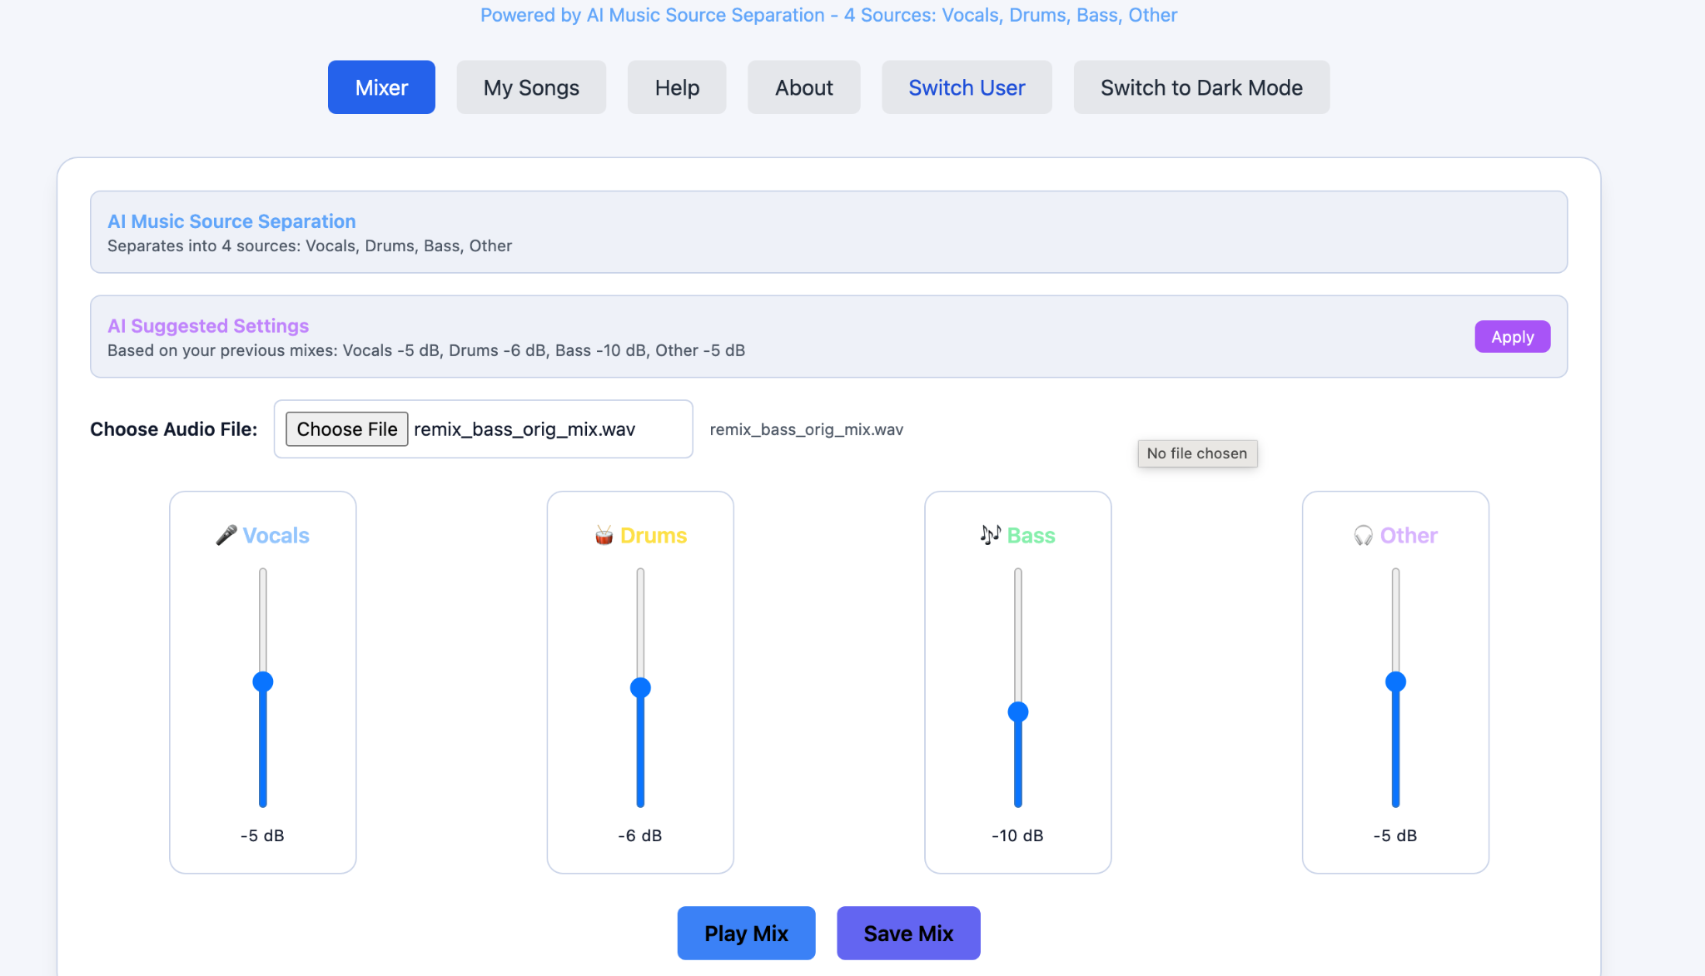
AI-Suggested Settings

4.5 User Delete Button
Some users indicated that there was no delete user option on the main page. This was an implementation error, since there could be privacy issues with not being able to delete users. For now, we have left the prototype as is, because we would prefer to implement a password-based login system in the future instead.

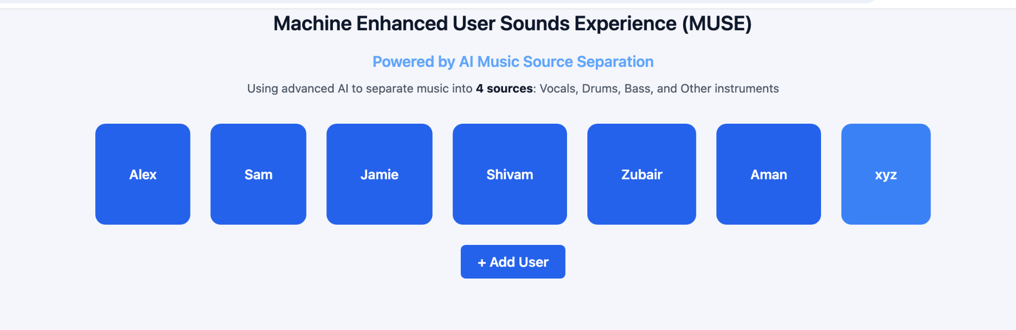
User Page

4.6 Explicit AI Contribution
We were recommended to include explicit AI contributions throughout the prototype to make the AI's role in the system clear. So we added prompts throughout the application to ensure clarity and transparency.

Default Page AI Message

User Page AI Message

